Task Management and Payment Reminders: Architecture and Logic
Oct 10, 2026 · @ClientCradle Technologies Private Limited

Overview
A payment reminder is an ordinary task. Task Management is the engine; Payment Reminders is a second way of creating and viewing the same task rows, with payment context added.
- Task Management lets a person create a task, assign it to themselves or someone below them in the org hierarchy, and work it through Open, In Progress, Paused and Completed. It runs on the web (TaskPro) and on Android.
- Payment Reminders lets an accountant set a dated reminder to chase money from a customer or for one invoice. It runs on the web (Accountant Panel) and, since the 9 Oct merge, on Android.
- The link between them is two columns on the task row: source_module and source_id. A task with source_module = PAYMENT_CUSTOMER points at a customer; PAYMENT_INVOICE points at an invoice. There is no separate reminders table.
- Amounts are never stored on the reminder. Outstanding and pending figures are always read live from the invoices.
This document describes the code on branch taskpro-integration of the ps-ops repository as read on 10 Oct 2026. It was written from the source; the Android reminders module was read but not run.

System architecture
Four clients share one backend, and the backend owns every rule: who may see a task, who may act on it, and when a reminder closes or alerts.
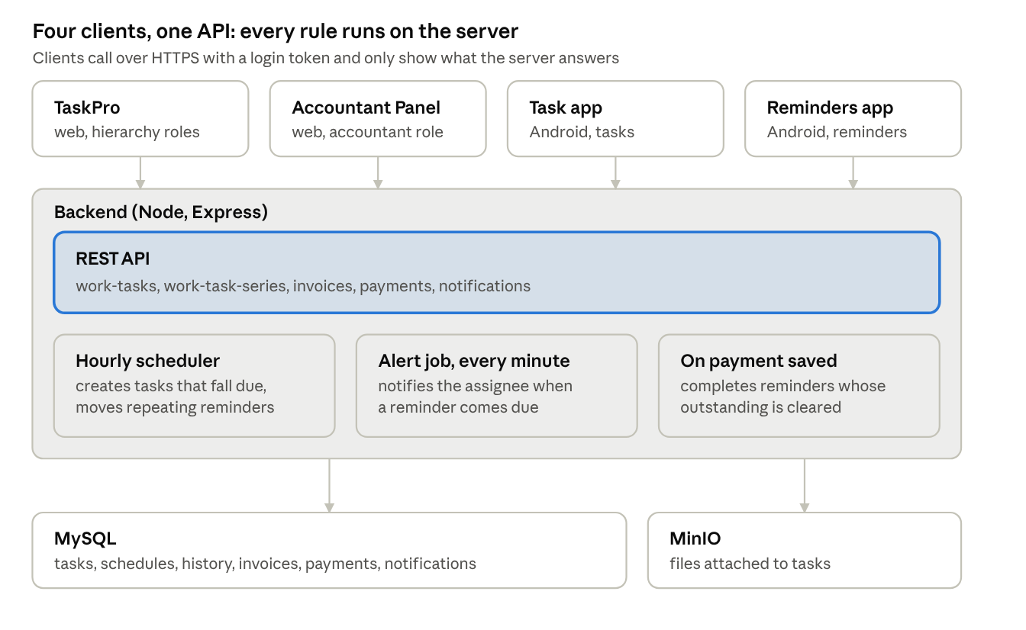
system architecture · 4 clients, 1 backend, 2 stores
Read it top down: a client sends a request, the REST API checks the rule and writes to MySQL, and three background pieces act without any client being open.
Layer | Where it is | Technology
Web clients | frontend/src/pages/taskpro, frontend/src/pages/accountant | React
Android clients | mobile/src/tasks, mobile/src/reminders | React Native
API | backend/src/routes, backend/src/controllers, backend/src/services | Node, Express
Background jobs | backend/src/utils/workTaskRecurrence.js, backend/src/jobs/paymentReminder.cron.js | Timers and node-cron inside the backend process
Database | Docker service ps-mysql locally | MySQL 8
File storage | Docker service ps-minio locally | MinIO
The backend code is built into its Docker image, so a code change needs the image rebuilt. Database migrations under backend/src/data/migrations are applied by hand.

Data model
Seven task tables hold everything for both features; reminders add no table of their own and only read the payment tables.
Table | Holds | Key columns
work_tasks | One row per task or reminder | status, priority, task_type, assigned_to, created_by, due_date, due_time, source_module, source_id, series_id, started_at, paused_at, paused_seconds, completed_at, completion_note
work_task_series | A repeating schedule (the template) | status (ACTIVE, PAUSED, CANCELLED), pause_from, pause_until, source_module, source_id, assigned_to
work_task_recurrence | The rule of a schedule | frequency, interval_value, days_of_week, day_of_month, month_week, time_of_day, start_date, end_type, end_date, end_count, occurrences_created, last_generated_until
work_task_history | Audit trail, one row per action | action (CREATE, START, PAUSE, RESUME, UPDATE, RESCHEDULE, COMPLETE, REOPEN, REASSIGN, SKIP, ATTACH, DETACH), from_status, to_status, note, changed_by
work_task_comments | Comments and progress notes | task_id, user_id, comment
work_task_attachments | File metadata; the file itself is in MinIO | object_key, file_name, file_type, file_size
work_task_reschedule_requests | An assignee asking to move a due date | status (PENDING, APPROVED, REJECTED, WITHDRAWN), to_due_date, to_due_time, reason, decided_by
Tables that reminders read or write outside the task set:
Table | Used for
invoices | Customer name, invoice number, pending_amount; the source of every amount shown
payments | Last payment date and the history timeline
customer_payment_contacts | The accountant's own phone list per customer: name, phone, email, is_primary, is_active
notifications | The "payment reminder due" alert, type PAYMENT_REMINDER
companies | The customer; its id (for example COMP110) is the source_id of a customer reminder
A reminder's task_type is always the text Payment Follow-up. The screens show it as "Payment Reminder".

Task backend: endpoints and permission rules
Every rule lives on the server; the web and Android clients only call these endpoints and show the answer. The code is in backend/src/routes/work-tasks.routes.js, work-task-series.routes.js and backend/src/utils/workTasks.js.

Who can see a task
The user has | Sees tasks assigned to
Admin role, or VIEW_ALL_WORK_TASKS | Everyone
VIEW_TEAM_WORK_TASKS or MANAGE_TEAM_WORK_TASKS | Themselves and everyone below them in the org hierarchy
None of these | Themselves only
A user always sees tasks they created. A task the user may not see answers 404, never 403, so the response does not reveal that it exists.

Who can do what
Action | Allowed for
Create and assign | Yourself always; someone else only with MANAGE_TEAM_WORK_TASKS and only if they are in your team; admin anyone
Start, pause, resume, add progress, complete | The assignee, or admin
Edit title, description, type, priority | The creator, admin, or a manager of the assignee. Being the assignee is not enough
Reschedule, skip one occurrence | Same as edit
Reassign | Same as edit, plus a manager may pass on a task assigned to themselves
Reopen a completed task | The assignee, or anyone who may edit
Ask for a reschedule | The assignee, when they may not reschedule directly. One pending request per task
Approve or reject a request | Anyone who may edit the task
Delete | The creator only. It removes comments, files, requests and history too
Comment, attach a file | Anyone who can see the task, but not on a finished task, and the assignee must start it first

Endpoints
Group | Endpoints under /api/work-tasks
Read | GET /, GET /:id, GET /types, GET /:id/history, GET /:id/comments, GET /:id/attachments, GET /notifications
Create and edit | POST /, PUT /:id, DELETE /:id
Lifecycle | POST /:id/start, /pause, /resume, /progress, /complete, /reopen, /reassign, /reschedule, /skip
Reschedule requests | GET /reschedule-requests, POST /:id/reschedule-requests, POST /reschedule-requests/:rid/approve, /reject, /withdraw
Files and comments | POST /:id/comments, POST /:id/attachments, GET /:id/attachments/:aid/view, DELETE /:id/attachments/:aid
Schedules (/api/work-task-series) | GET /, GET /:id, POST /:id/pause, /resume, /stop

Safety rules built into every write
- Guarded status changes. Each change updates the row only if the status is still what was checked, so two people acting at once cannot both succeed; the loser gets a 409.
- History in the same transaction. Every action writes its work_task_history row together with the change.
- Uploads. One file per request, 10 MB at most, stored in MinIO. Only images and PDFs open in the browser; everything else downloads.

Task lifecycle
A task has five statuses; Open, In Progress and Paused count as active, Completed and Cancelled as finished. A reminder uses the same statuses.
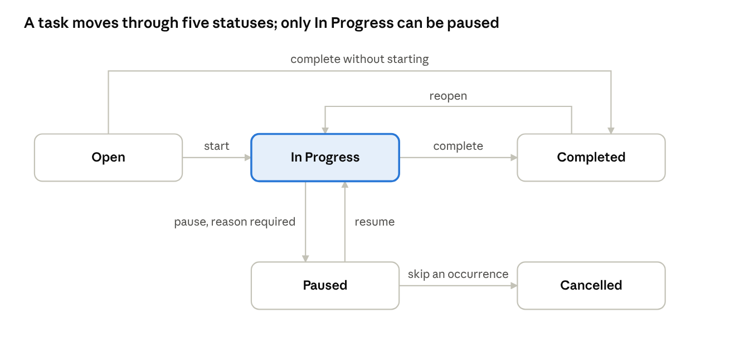
task lifecycle · 5 statuses, 7 transitions
Skip is drawn from Paused but applies to any active occurrence of a recurring task. A finished task accepts no edit, reassign, reschedule, comment or file until it is reopened.
Action | From | To | What else happens
Start | Open | In Progress | Records who started it and when
Pause | In Progress | Paused | A reason is required; the clock stops
Resume | Paused | In Progress | The paused time is added to paused_seconds, so it is left out of time worked
Add progress | In Progress | In Progress | Saves the note as a comment; can set the next action
Complete | Open or In Progress | Completed | Records who and when, with an optional note. A paused task must be resumed first
Reopen | Completed | In Progress | Clears the completion fields
Reschedule | Any active | Unchanged | Moves the due date; rejects any reschedule request still waiting. The new date cannot be in the past
Reassign | Any active | Unchanged | Changes the assignee; the new assignee must be someone the user may assign to
Skip | Any active occurrence of a recurring task | Cancelled | The schedule carries on
Auto-complete on payment | Any active reminder | Completed | Done by the server when the outstanding is cleared; a paused reminder's paused time is settled first

Recurring tasks
A recurring task is a schedule plus one rule; each due date becomes an ordinary task row. The logic is in backend/src/utils/workTaskRecurrence.js.

The rule
Frequency | Falls due on
DAILY | Every N days counted from the start date
WEEKLY | The chosen weekdays, every N weeks
MONTHLY | A day number (the last day in shorter months), the last day of the month, or an "Nth weekday" such as the 1st and 3rd Monday
YEARLY | A month and day, every N years
A rule ends never, on a date, or after a number of occurrences. A new schedule may start at most 366 days in the past.

How occurrences are created
- A scheduler runs 8 seconds after the backend starts, then once an hour.
- For every schedule that is ACTIVE or PAUSED it creates each occurrence due on or before today that does not exist yet, at most 100 per run.
- Occurrences are created on the day they fall due, not ahead of time. The schedule row is locked while this happens, so two runs can never create the same occurrence twice.
- Creating a schedule through POST /api/work-tasks runs the same step straight away, so occurrences already due appear at once.
- If the assignee is no longer an active user, nothing is created.

Pause, resume, stop, skip
Action | Effect
Pause | Dates inside the pause window are skipped for good. A pause with an end date lifts itself after that date
Resume | Clears the pause and creates today's occurrence if due. Days missed while paused are not back-filled
Stop | Permanent. No more occurrences; ones already created stay as they are
Skip | Cancels one occurrence. The schedule and every other occurrence are untouched

The exception for payment reminders
A schedule whose source_module is PAYMENT_CUSTOMER or PAYMENT_INVOICE behaves differently: it stays one reminder instead of making a new task per date. The Payment reminder backend logic section describes this.

Task notifications
There are two separate mechanisms: the web reads a feed the server builds, and the Android task app works events out on the phone.

Server feed (web TaskPro)
GET /api/work-tasks/notifications returns what other people did that concerns the caller, newest first, from the last 30 days. It has no table of its own; it is built on each request from history, comments and reschedule requests.
On | Events included
Tasks assigned to me | Assigned or reassigned to me, due date moved, edited, reopened, skipped, cancelled, file added
Tasks I created for others | Started, paused, resumed, completed, reopened, file added
Either | Comments and progress updates
Reschedule requests | Someone asked me to approve one; my own request was approved or rejected
Nothing the caller did themselves is included. Occurrences generated by a schedule are left out to avoid daily noise.

On-device detection (Android task app)
mobile/src/tasks/notifications.ts does not call the server feed. It works like this:
- The app refetches the whole task list every 60 seconds and when it returns to the foreground.
- It compares each task's status with the last status it remembered.
- A change produces one of five events: created, started, paused, resumed, completed.
- Each event has a key so it is shown once. The last 30 are kept in the bell, stored per user on the phone.
- The first run for a user only records statuses and announces nothing.
Events appear only while the app is open. There is no push notification.

Web TaskPro module
TaskPro is a self-contained area under frontend/src/pages/taskpro/, opened by the org-hierarchy roles listed in access.js. Only tasksApi.js talks to the backend. The descriptions below come from each file's own header comment and its API calls; the files were not read line by line.
File | Responsibility
access.js | Which roles may open TaskPro. A client-side gate only; the server enforces the real rules
tasksApi.js | The only file that calls /api/work-tasks and /api/work-task-series
ViewerProvider.jsx, viewerContext.js | The signed-in person: id, role, team and the org directory from the hierarchy API
hierarchy.js, OrgTree.jsx | Helpers and the tree view of the people below the viewer
TaskProLayout.jsx | The shell: side navigation, the bell and the New task button
TaskDashboard.jsx, charts.jsx, prefs.js | Dashboard cards and charts; clicking a chart filters the dashboard; card choices are remembered per browser
TaskList.jsx, selectors.js, Filters.jsx | The list screens (My Tasks, Team Tasks, Completed and others) as one component with filters
TaskDetail.jsx | One task: actions, time worked, comments, files, history
NewTaskModal.jsx | Create a one-time or recurring task, including the recurrence rule
SeriesDialog.jsx, NotStartedSeries.jsx | A schedule's rule, next date and Pause, Resume, Stop; and schedules whose first date has not arrived
RescheduleRequests.jsx | "Waiting for me" to approve or reject, and "My requests"
Notifications.jsx, notify.js | The notifications page and bell, reading the server feed
TaskReports.jsx, reportDoc.js, xlsx.js | Reports for a period, with PDF and Excel downloads
TaskProfile.jsx | The viewer's own profile and reporting line
format.js, data.js, ui.jsx, useNow.js, ToastProvider.jsx, toastContext.js | Date formatting, fixed vocabularies, shared dialog and form parts, a clock, toasts
Routes: the TaskPro home plus requests, reports, profile and notifications, all inside TaskProLayout.

Android Task module
The Android task app is a React Native module under mobile/src/tasks/, shown to the org-hierarchy roles and to the accountant. It keeps one shared task list in memory and every screen filters that list.

Data flow
- RoleTabs.tsx checks the signed-in role and mounts TaskNavigator.
- TaskNavigator.tsx wraps everything in TasksProvider and defines the tabs and screens.
- TasksContext.tsx loads GET /api/work-tasks once, then every 60 seconds and on return to the foreground.
- A screen calls a function in api.ts; the server's answer is patched back into the shared list, so every tab updates.
- A refused action comes back as an error and is shown as a toast.

Files
File | Responsibility
api.ts | One function per endpoint: list, create, edit, start, pause, resume, progress, complete, reassign, reschedule, skip, delete, comments, attachments, history, schedule pause, resume and stop
TasksContext.tsx | The viewer, the shared task list, who the viewer may assign to, toasts, and the notification list
notifications.ts | Works out events by comparing task statuses between refreshes
format.ts | Date and time formatting, overdue and due labels, and the list filters (My, Team, Today, Overdue, Upcoming, Completed, In Progress, High Priority, Assigned by Me, Recurring)
types.ts | The shapes the API returns
theme.ts | Maps task state and priority to colours
navigation.ts | Screen names and their parameters
ui/parts.tsx, ui/sheets.tsx, ui/taskIcons.tsx, ui/NotificationToast.tsx | Shared header, avatar, bottom sheets, icons and the notification pop-up

Screens
Screen | What it does
TaskHomeScreen | Header with name and role, three tiles (Today's Tasks, Overdue, Upcoming), the three newest tasks, Quick Actions
TaskListScreen | The full list with a filter mode and search
NewTaskScreen | Create a one-time or recurring task and choose the assignee
TaskCreatedScreen | Confirmation after creating
TaskDetailScreen | One task with every action, comments, files and history
TaskActionScreens | Reassign and Reschedule
TaskScheduleScreen | Calendar view of due dates
TaskInsightsScreen | Summary figures
TaskNotificationsScreen | The bell list
TaskProfileScreen | Own counts, team, change password, sign out
Bottom tabs: Home, Tasks, a raised New Task button, Calendar, Insights.

Payment reminder backend logic
A reminder is created, worked and closed through the task endpoints; only three pieces of logic are payment-specific: closing when paid, alerting at the due time, and how a repeating reminder carries on.

Creating a reminder
Both clients send POST /api/work-tasks with these fixed values:
Field | Value
task_type | Payment Follow-up
title | Payment Reminder - <customer> plus the invoice number for an invoice reminder
source_module, source_id | PAYMENT_CUSTOMER and the customer id, or PAYMENT_INVOICE and the invoice id
assigned_to | Always the person creating it
due_date, due_time | For a one-time reminder
recurrence | For a repeating reminder, built from the first date and time
Ticking several invoices creates one reminder per invoice. Before creating a repeating reminder the client checks that no running schedule exists for the same customer or invoice; this check is in the client only.

Recording a call outcome
Saving an outcome is up to three calls in a row: start the reminder if it is Open (or resume it if Paused), add a progress note with the outcome text, then reschedule if a new date was given. The outcomes offered are Payment received, Will pay today, Call me later, Payment date confirmed, Dispute / Query, No response and Other.

Closing when the money arrives
backend/src/services/PaymentFollowUp.service.js runs right after a payment is saved. A failure here never fails the payment.
- It loads the customer's open reminders and current invoice balances.
- A whole-customer reminder is completed when the customer owes nothing.
- An invoice reminder is completed when that invoice owes nothing, or the customer owes nothing.
- Each one gets the completion note "Outstanding cleared (payment <number>)" and a COMPLETE history row.
- A repeating schedule for a paid invoice is cancelled. A repeating schedule for the whole customer keeps running.

Alerting at the due time
backend/src/jobs/paymentReminder.cron.js runs every minute, and once at startup.
- It finds open reminders whose due moment has arrived within the last day. The due moment is the due date plus the due time, or 9:00 AM when no time is set.
- It skips any reminder that already has a PAYMENT_REMINDER notification created at or after that due moment.
- It writes one notification to the assignee: "Payment reminder: <customer>", with the amount outstanding.
Because step 2 compares against the current due moment, a rescheduled reminder alerts again at its new time. Reminders more than a day late do not alert; they only show as Overdue.

How a repeating reminder carries on
- The one reminder is created the moment the schedule is saved, even when the first date is still ahead.
- Each time the hourly scheduler finds the next date has arrived, it moves that same reminder to the new date and the schedule's time, and writes a RESCHEDULE history row "Repeating reminder".
- When the reminder is completed or cancelled, the next scheduler run cancels the schedule. It does not start a new reminder.

Customer contacts
customerPaymentContacts.controller.js serves the accountant's own phone list under /api/invoices/customers/:customerId/....
- A non-admin user only reaches customers that have a site, or an invoice at a site, in the user's branch.
- The same number cannot be saved twice for one customer; spaces and dashes are ignored.
- A customer's first number becomes primary. Marking another as primary removes the mark from the rest.
- Archiving hides a number without deleting it; if it was primary, the oldest remaining number becomes primary.

Web Accountant reminder modules
The reminder screens live in the Accountant Panel, open to the accountant role only. Every screen gets its data from one hook, useAccountantData(), which loads all invoices, all payments and all reminders when a page opens.

Shared data layer
File | Responsibility
pages/accountant/data.js | useAccountantData(); cleans invoice, payment and reminder rows; groups invoices by customer; works out the status label (Today, Overdue, Upcoming, Completed, Cancelled)
pages/accountant/followups.js | Every reminder action: create, start, record outcome, reschedule, complete, reopen, comments, attachments, schedules, and the customer contact calls
layouts/AccountantLayout.jsx | The side menu (Dashboard, Invoices, Payments, Tasks & Reminders, Contacts, TDS) and the place where reminder pop-ups are mounted

Screens and components
File | What it does
pages/accountant/TaskManagement.jsx | The Tasks & Reminders page. Tabs All, Today, Overdue, Upcoming, Completed and Repeating; filters by scope, priority, customer and due date; Stop on a repeating schedule
components/accountant/FollowUpModal.jsx | Create Payment Reminder: customer, Entire Customer or Specific Invoice, Repeat, date, time, optional end date, priority, notes
pages/accountant/FollowUpDetails.jsx | One reminder: actions (Call Customer, Start, Update Reminder, Complete, Record Payment, Reopen), the progress track, and tabs Payment Info, Details, History, Comments, Attachments
components/accountant/FollowUpOutcomeModal.jsx | Update Reminder after a call: the outcome, an optional next date and time, remarks
components/accountant/CustomerReminderPanel.jsx | The side panel on Customer Outstanding. Bell mode shows contacts, unpaid invoices and every open reminder; clock mode shows the customer's activity timeline
components/accountant/CustomerContacts.jsx | The contact cards with Call, Edit and Add another
components/accountant/CallDialog.jsx | The Call Customer pop-up: name, number, Copy Number
pages/accountant/CustomerContactsPage.jsx | The Contacts page: every saved number, with archive and restore
components/accountant/ReminderAlerts.jsx | Pop-ups for reminders that have just come due; checks every 30 seconds and when the tab regains focus
pages/accountant/RecordPayment.jsx | Record a payment against invoices; reached from a reminder with the customer pre-selected

The progress track on a reminder
The track is worked out from the reminder as it is now; nothing extra is stored.
Step | Ticked when
Created | Always
Started | The status is no longer Open
Customer Contacted | The history has at least one update
Rescheduled | The history has at least one reschedule. Never shown as the "next" step
Payment Received | The outstanding it points at is zero
Completed | The status is Completed (or Cancelled)

Changes made on 9 and 10 Oct 2026
- Record Payment no longer shows a negative Balance after saving; the table freezes on the invoices just paid.
- Call Customer opens a pop-up instead of the browser's "choose an app" prompt, on the reminder page and on the contact card.
- The progress track gained the Rescheduled step.
- The side panel lists every open reminder for the customer, not only the next one.

Android Reminders module
The Android reminders app is a second module under mobile/src/reminders/, added by the commit accountant-android updated on 9 Oct 2026. An accountant opens in Task Management and switches to Payment Reminders and back without signing out. This section comes from reading the code; the app was not run.

The app switch
File | Responsibility
auth/role.ts | isAccountantRole() is true for the role accountant
navigation/RoleTabs.tsx | Decides which app is showing. An accountant has two: tasks and reminders. Managing Director and Personal Assistant have tasks and sales
navigation/AppSwitchContext.tsx | Tells each Home screen whether the user can switch and which app is current
navigation/AppSwitchSheet.tsx | The "Switch app" sheet that hangs under the avatar on each Home, with a "My profile" link
When the user picks the other app, the current one is unmounted first and the other mounted 80 ms later. The code notes that swapping them in one step leaves the screen stack unable to open screens.

Data flow
- RemindersNavigator.tsx wraps the screens in RemindersProvider.
- RemindersContext.tsx loads three lists together: invoices, reminder tasks (GET /api/work-tasks?task_type=Payment Follow-up) and running schedules.
- It joins them so each reminder carries its customer name, invoice number and live amounts.
- Screens call reminders/api.ts, which reuses the task module's functions (tasks/api.ts) for start, resume, progress, reschedule and complete.
- After a change the screen calls reload(). There is no timed refresh in this module.

Files
File | Responsibility
api.ts | List invoices, reminders and schedules; create a reminder; record an outcome; complete; reopen; stop a schedule; read and add customer contacts
RemindersContext.tsx | The shared lists, the customers with money outstanding, the signed-in user, toasts
format.ts | Cleans invoice and reminder rows, builds the recurrence rule from the first date, the repeat sentence, the outcome list
types.ts | Shapes and the fixed values Payment Follow-up, PAYMENT_CUSTOMER, PAYMENT_INVOICE
ui.tsx, navigation.ts | Shared parts and screen names

Screens
Screen | What it does
ReminderHomeScreen | Same shape as the task Home: header band, stat tiles, quick actions
ReminderListScreen | Every reminder under All, Today, Overdue, Upcoming, Completed, with the live outstanding
Repeating tab | Running schedules, with Stop
CreateReminderScreen | Whole customer or one or several invoices; same rules as the web dialog
ReminderDetailScreen | What is owed, who to call, notes and history, with the update and complete actions
ReminderProfileScreen | The accountant's reminder numbers, change password, sign out
Bottom tabs: Home, Reminders, a raised Create Reminder button, Repeating, Profile.

Date and time rules
A reminder's date decides its label and its date plus time decides when it alerts.

On the create form
- The date is required and cannot be in the past; today is allowed.
- The time is required and starts at 10:00 AM. It is not compared with the current time.
- For a repeating reminder the first date sets the repeat day: the same weekday for Weekly, the same day number for Monthly.
- An end date is optional and cannot be before the start date.

Status label
Reminder date | Label
A future day | Upcoming
Today, at any time | Today (shown as "Due today")
Before today | Overdue
The label uses the date only. A reminder set for 5:00 PM today stays "Due today" after 5:00 PM and turns Overdue the next day.

Alert timing
Step | Runs | Worst-case delay
Server looks for reminders that have come due | Every minute | 1 minute
Web panel looks for new notifications | Every 30 seconds, and when the tab regains focus | 30 seconds
Scheduler moves a repeating reminder to its next date | Every hour | 1 hour
- A reminder alerts once for a given date and time; rescheduling it makes it alert again.
- An alert missed while the server was down is still sent if the server returns within one day.
- The pop-up needs the Accountant Panel to be open. Otherwise the notification waits in the bell.
- The due moment is compared with the database server's clock. The local Docker database runs on India time. The production server's clock has not been checked.

Where dates are compared
Place | Uses
Server "overdue" flag and "not in the past" checks | The database's current date
Web and Android labels | The device's local date
Calendar dates travel as plain YYYY-MM-DD text and times as HH:MM:SS, so a date does not shift between time zones on the way.

Known gaps and risks
These were found while reading the code. None has been fixed unless the row says so.
Area | Gap | Effect
Task list API | GET /api/work-tasks has no paging | The Android task app refetches every visible task each minute; slow for admins and heads as data grows
Accountant data | Every page loads all invoices, all payments and all reminders | Pages slow down as invoices grow; totals are worked out in the browser
Android task notifications | Worked out on the phone; no push; the server feed is unused | Nothing arrives while the app is closed; comments, reassignments and reschedule requests are never announced
Android task notifications | The "shown once" key has no timestamp for created, started and completed | A task completed, reopened and completed again is announced only once
Android task app | No "ask for a reschedule" and no "reopen" | An assignee who cannot move a due date has no way to ask from the phone
Repeating reminders | The "already has a repeating reminder" check is in the client only | Two tabs or a direct API call can create two schedules for one customer
Call outcome | Up to three separate calls, not one transaction | If the last call fails, the note is saved but the date does not move
Cancelled invoices | A reminder on a cancelled invoice stays open until the customer's next payment, then closes as "Outstanding cleared" | The closing note is wrong for that reminder
Completed repeating reminder | The schedule stays listed with a dash under Reminder Due until the next hourly run | Looks like a broken row for up to an hour
Alert job | Its "already running" guard is per process | With more than one backend instance the same alert can be sent twice
Alert time | Compared with the database clock; db.js sets no time zone | If production MySQL is not on India time, alerts fire at the wrong hour. Not checked on production
Overdue | Server uses the database date, clients use the device date | The two can disagree around midnight
Android reminders | No timed refresh | A reminder changed on the web shows on the phone only after a reload
Contacts permission | Adding or editing a customer phone number needs CREATE_PAYMENT | A user who may view invoices but not record payments cannot save a number
Database migrations | Applied by hand; there is no runner | A backend newer than the database fails at runtime. This happened locally on 9 Oct with the missing month_week column
Task types | GET /api/work-tasks/types returns every type in the organisation | A small information leak to any signed-in user
Delete | Only the creator can delete a task | An admin cannot remove a task created by someone else

